Io Eclipse Data Roundup and Summary

**APO:** UT180320, UT190812, UT200823, UT200908, UT201001, UT201017

**Keck:** UT180807

**LBT:** UT190424

Included in these summaries are waterfall plots of Na D and O6300. Other species are open for analysis, but the waterfalls are not included in this document for the sake of brevity.

Each waterfall contains information on which frames, if any, were rejected.

Pointing confirmation usually will not include images of ecam as this usually provides little information in eclipse, but will include a reference ecam file number which corresponds to science frame.

Additional helpful files are listed: in particular, for Na in sunlight analysis.

**APO**

**UT180320:**

Pointing was confirmed to be good for all frames.

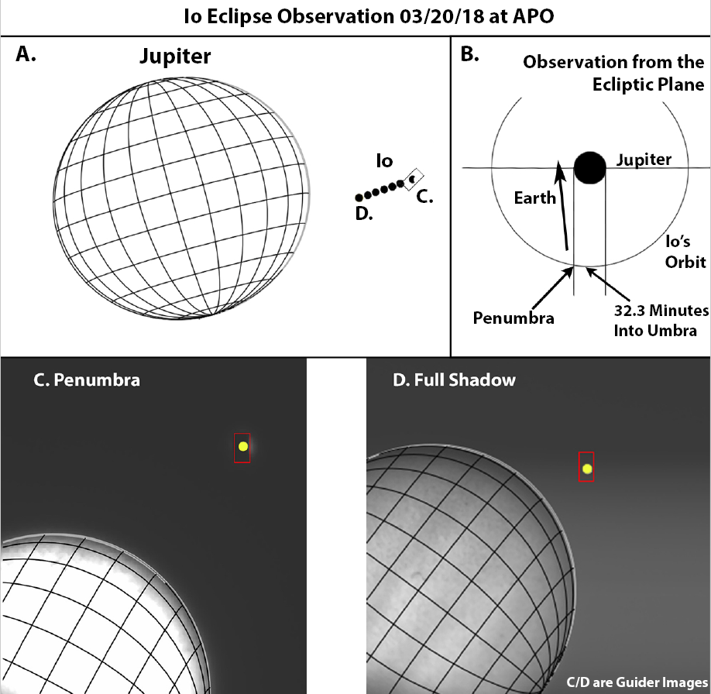

Na-D Waterfall:

No frames are rejected. Spectrum fits well.

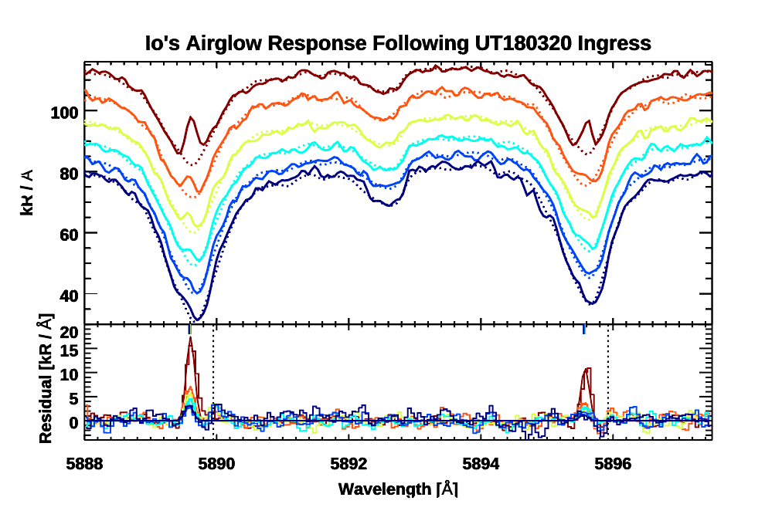

O6300:

No frames rejected. Fits accepted. Update 5/21

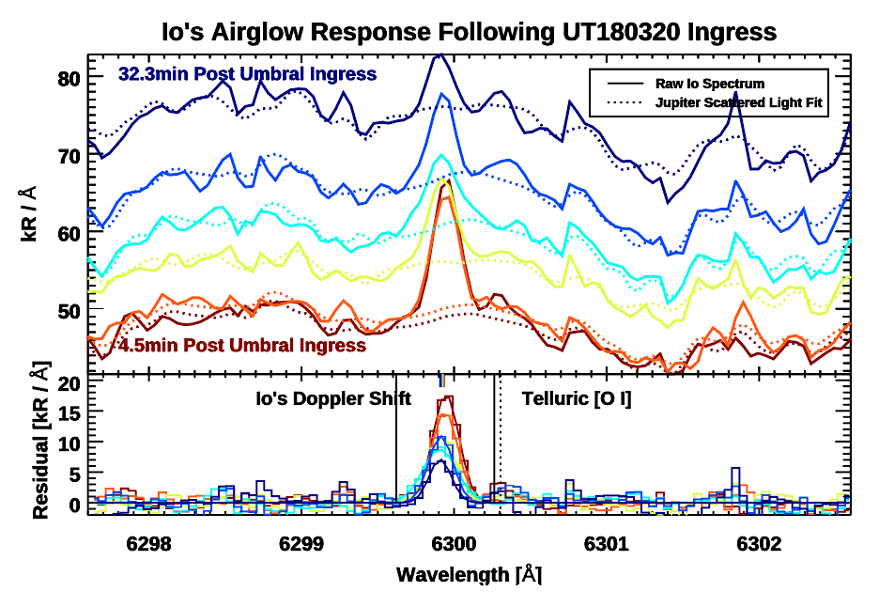

**Useful files: 6 Free and Clear + 1 penumbra**

**UT190812:**

Pointing was confirmed to be good for all frames. Previously checked. Ecam no longer on images server. Update 5/21

Useful Files: Ganymede + 4 sunlit + 1 penumbra frame

Na D waterfall:

No frames rejected. All fitting acceptable.

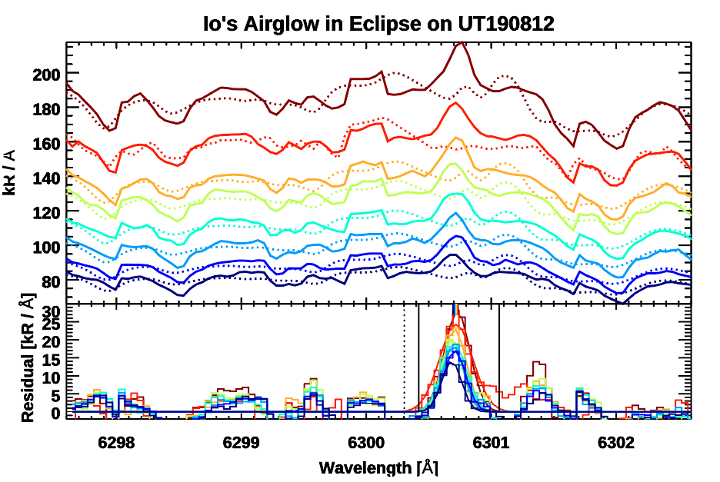

Boxiness due to telluric correction still present.

O6300:

No frames rejected. All fitting acceptable.

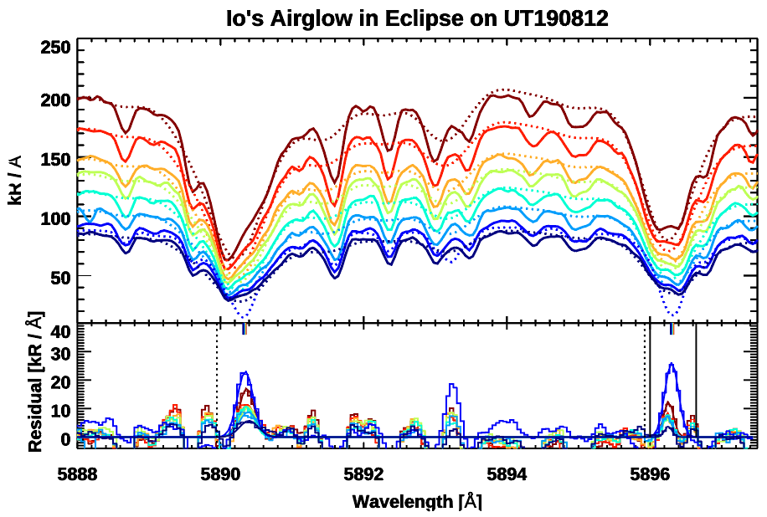

**UT200823:**

Frames present (1-8), pointing checked for 1(ecam0902), 2(ecam953), 4(ecam1129), 5(ecam1214), 7(ecam1352). All pointing good. None rejected.

Useful Files: Ganymede + 4 sunlit

Na D waterfall:

Poor fitting must be revised before use. Surface level modifications to fitting algorithm did not fix issue. Update 05/21

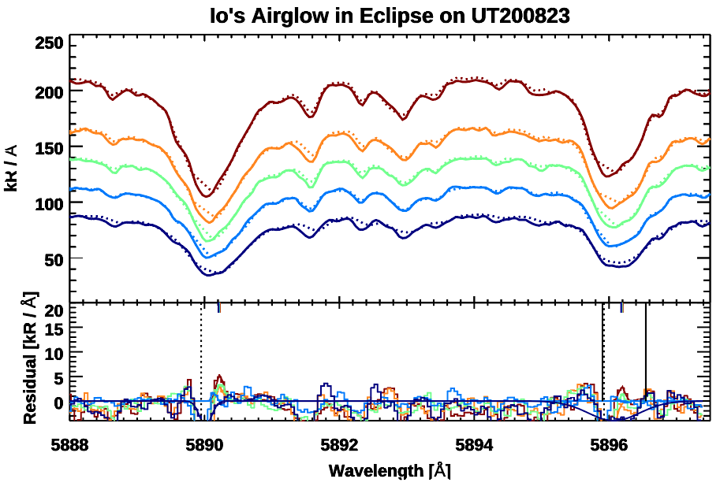

O6300 waterfall:

Very boxy, notably also present in the background. Not present in fullspec: likely due to telluric correction.

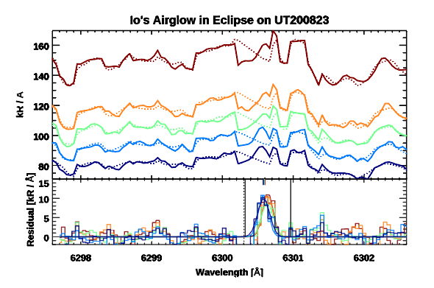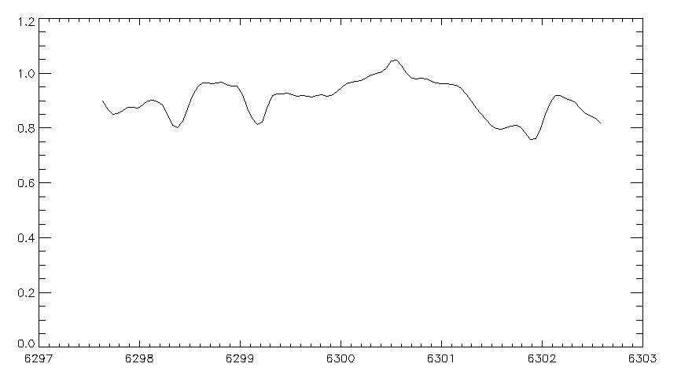

**UT200908:**

Frames present (19,20,23,25,26), pointing checked for 19(ecam0303), 23(ecam582), 25(ecam0742), 26(ecam0824). Pointing for 19, 23 is good therefore 19, 20, 23 are accepted. 25 26 rejected.

Useful Files: Ganymede + Europa + 6 sunlit + 1 penumbra

NaD Waterfall:

All fits accepted.

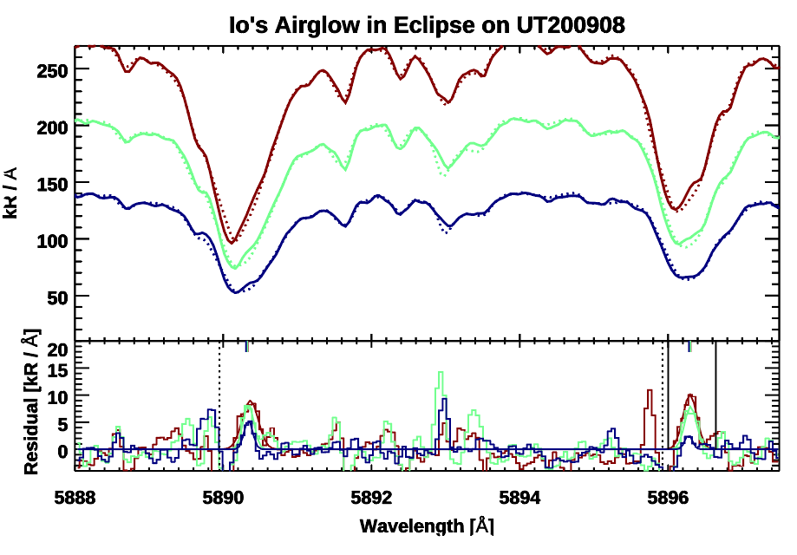

O6300:

Fit looks good, but once again box effect is present.

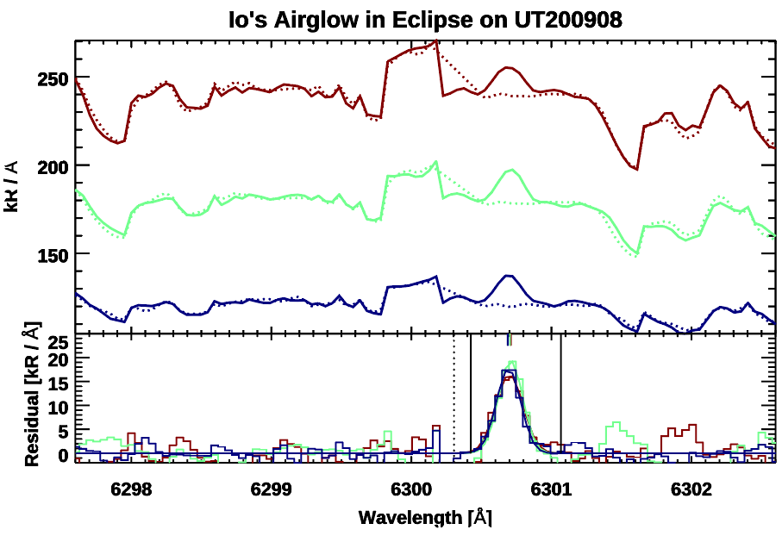

Once again this is not present in the fullspec.

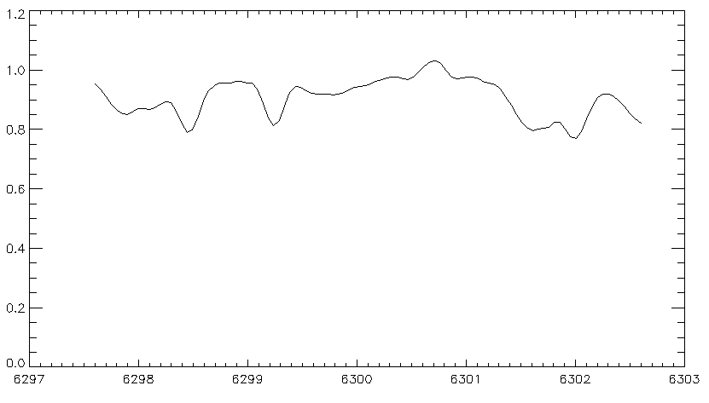

**UT201001:**

Pointing checked. Missing ecam numbers, will be re-found. All frames have good pointing, none rejected.

Useful files: Ganymede + 8 free and clear + 1 penumbra

NaD Waterfall:

No rejections. All acceptable fits.

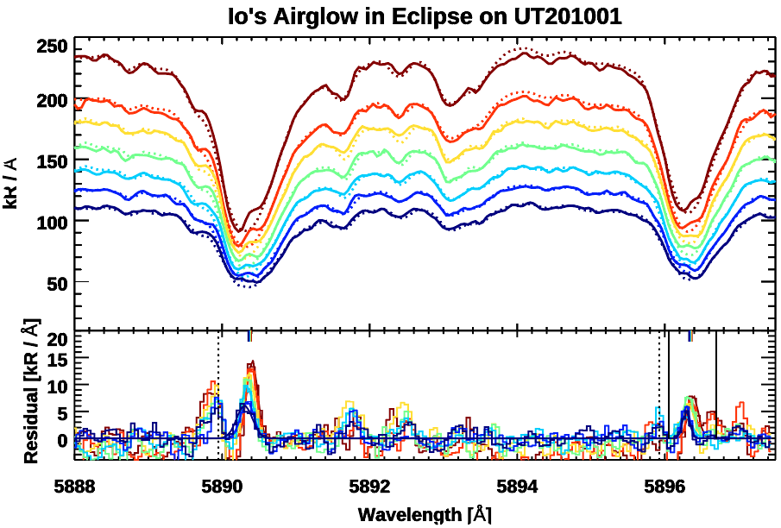

O6300:

No rejections. All acceptable fits.

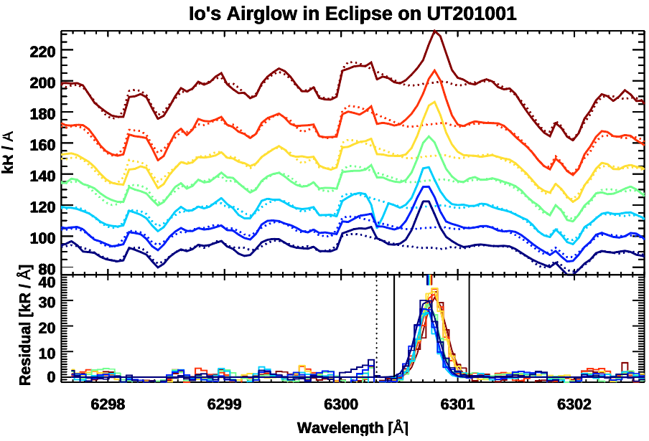

**UT201017:**

Frames present (16-20, 22,23,24), pointing checked for 20(ecam0345), 22(ecam495), 23(ecam0555), 24(ecam0615). Pointing for 22-24 is good therefore are accepted. 16-20 rejected.

However, 24 is in penumbra, therefore we reject this value for the moment.

Useful files: Callisto + 4 free and clear + 1 penumbra

NaD:

Fits accepted

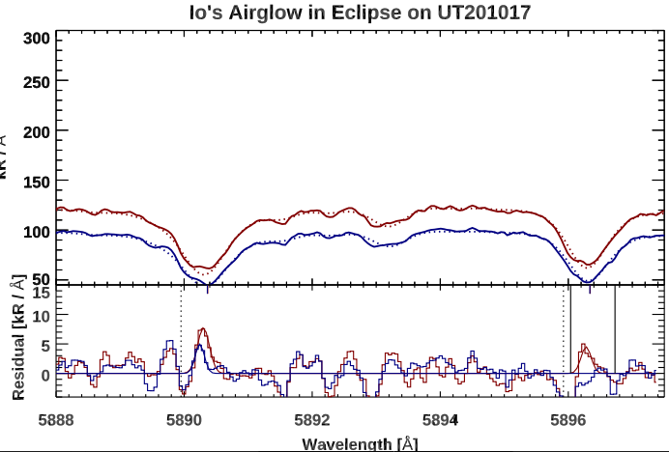

O6300:

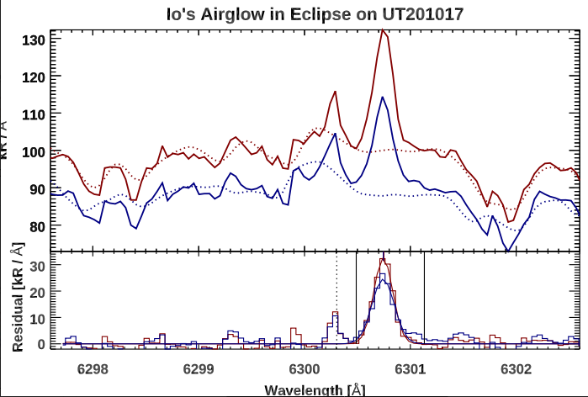

Should update for penumbra. Otherwise fit acceptable.

**Keck:**

**UT180807:**

Keck needs to be fixed due to the fact that the object does not fill the slit. No ecam data therefore frames not checked.

Na D:

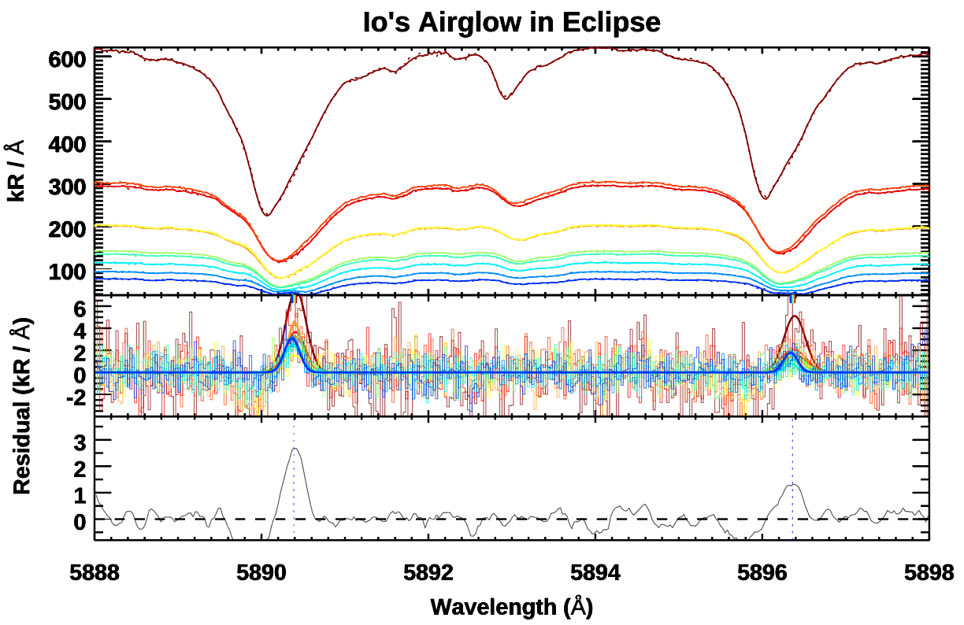

Fits look good, first brown frame is questionable in validity, but accepted.

O6300:

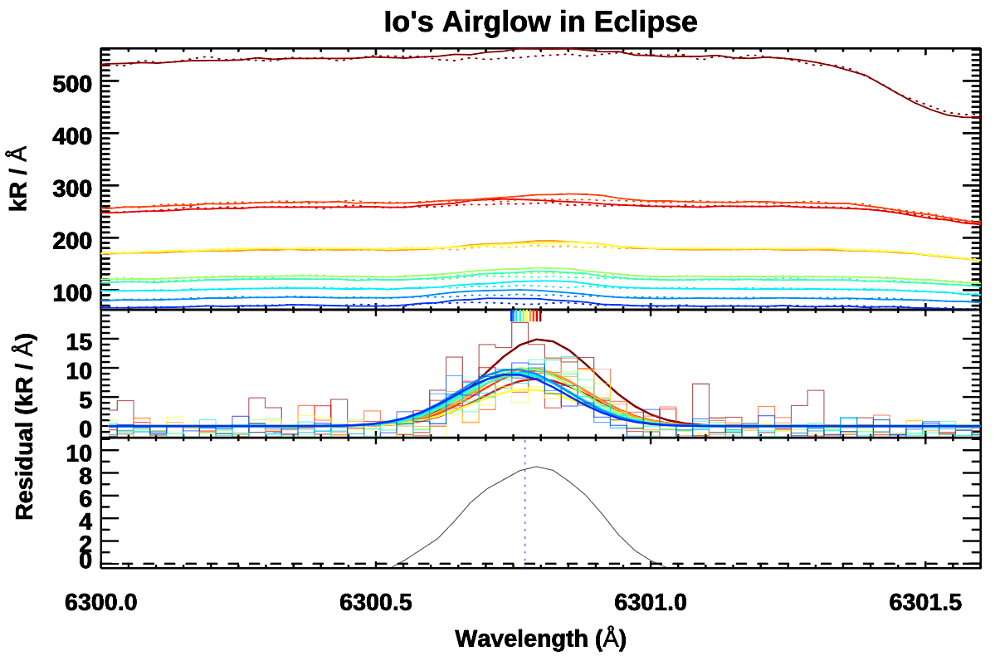

O6300 appears to be fine, all accepted.

**LBT:**

**UT190424:**

No ecam frames not checked. Good pointing assumed.

Na D:

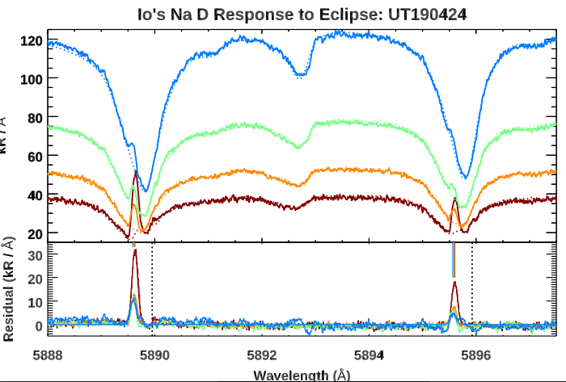

O6300:

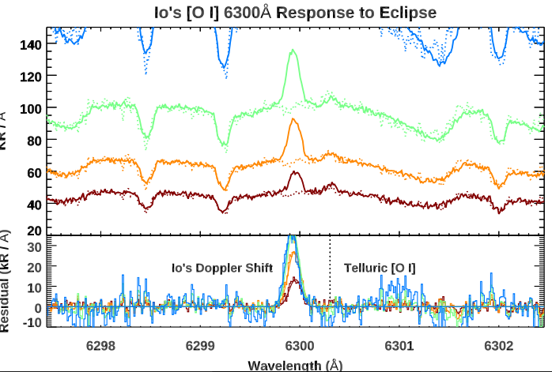

O6300 fit acceptable, all accepted.

Combined Plots (Torus, Egress, Ingress, etc.)

